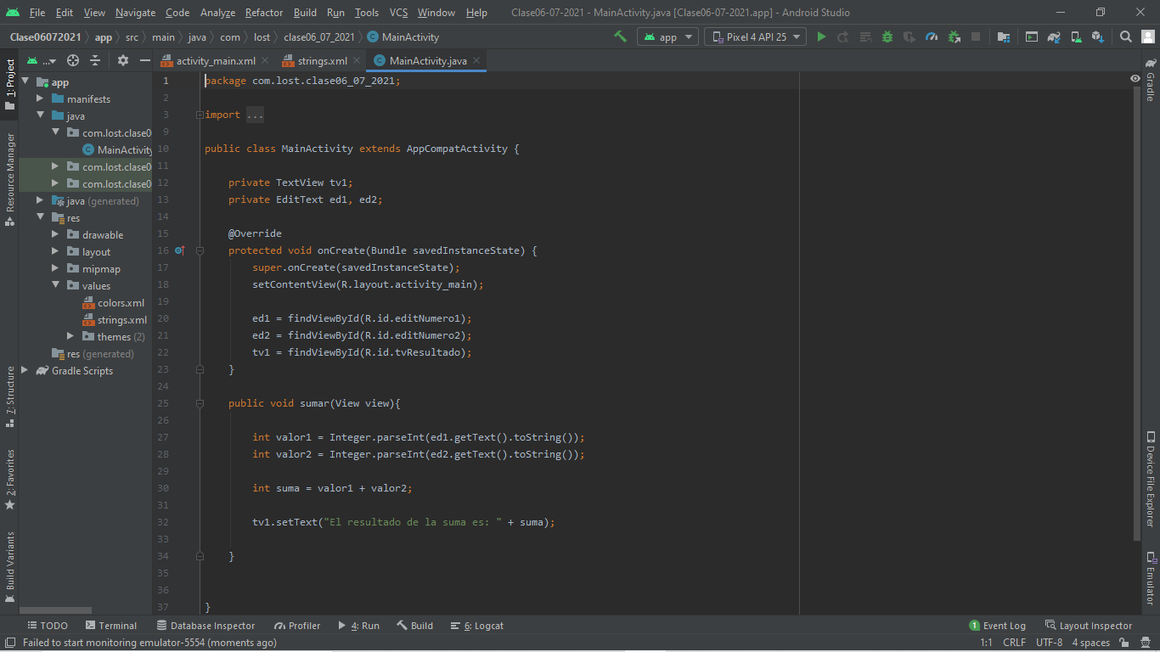
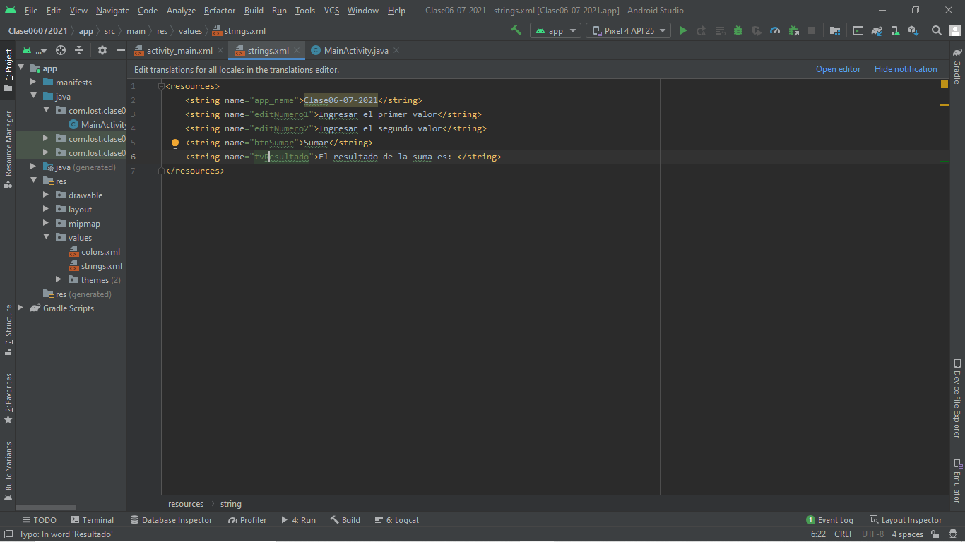

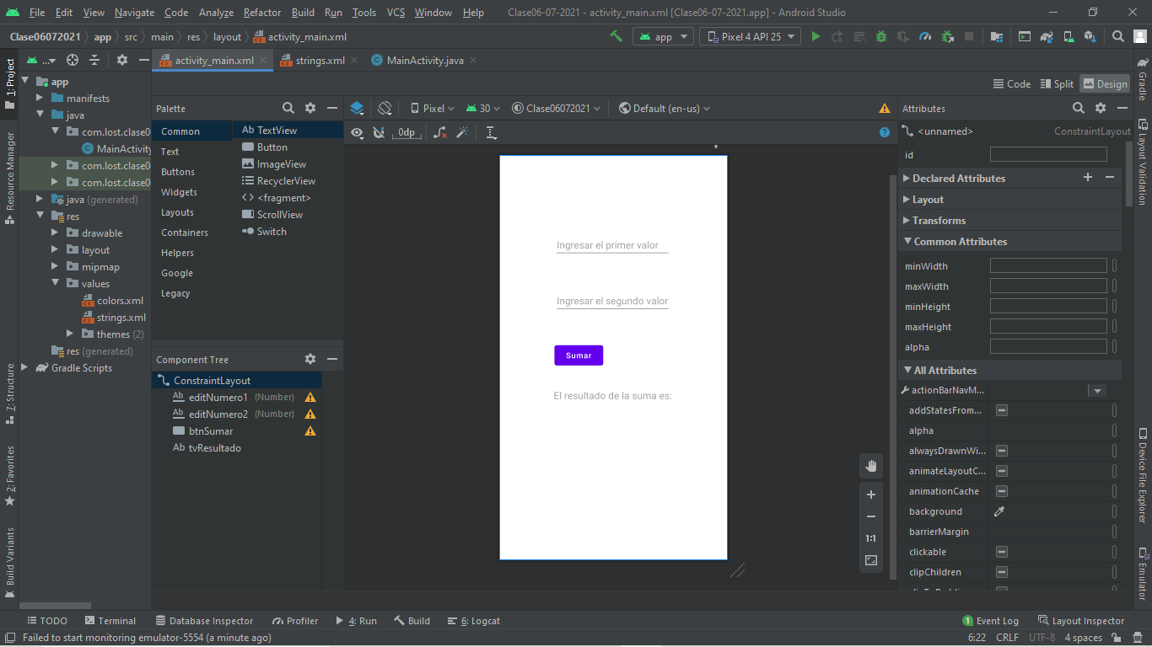

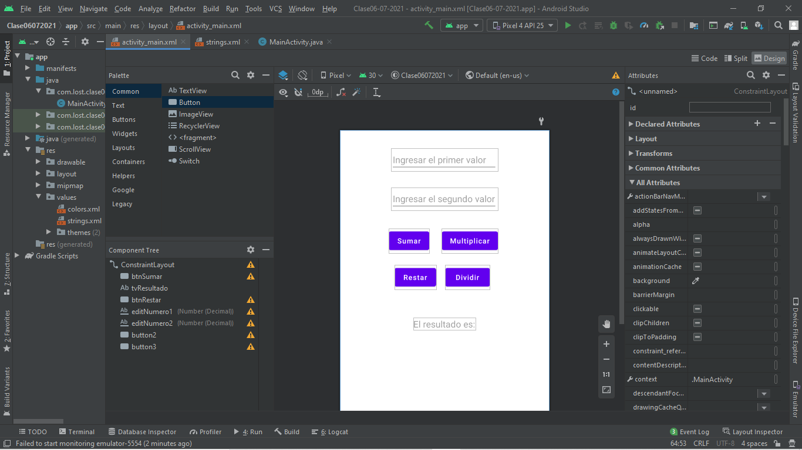

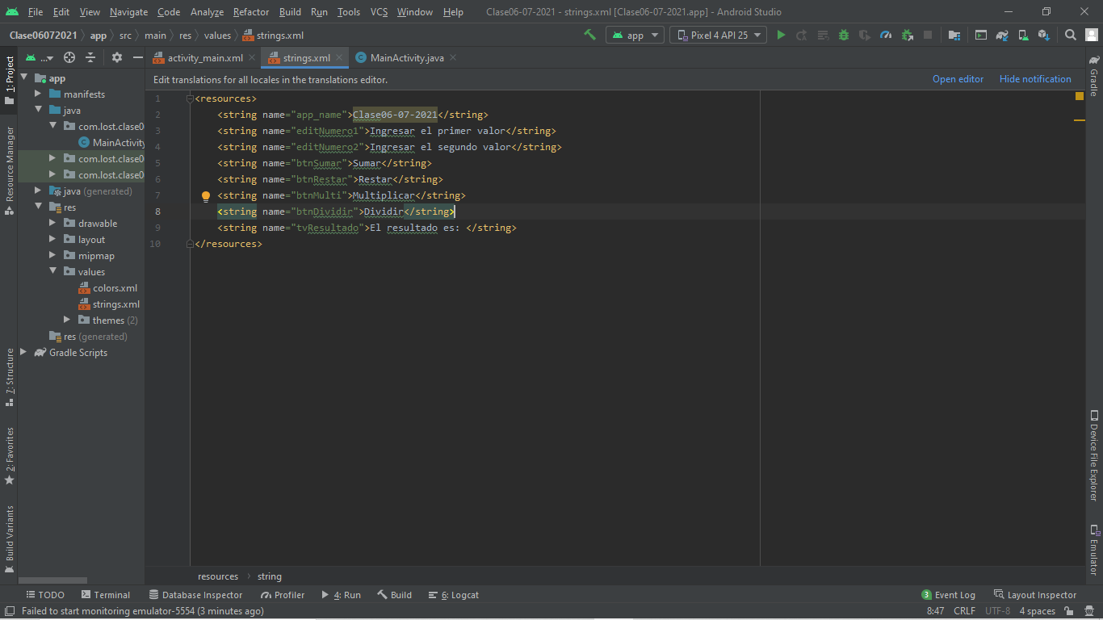

//Codigo
ackage com.lost.clase06_07_2021;
import androidx.appcompat.app.AppCompatActivity;
import android.content.Intent;
import android.os.Bundle;
import android.view.View;
import android.widget.EditText;
import android.widget.TextView;
public class MainActivity extends AppCompatActivity {
private TextView tv1;
private EditText ed1, ed2;
@Override
protected void onCreate(Bundle savedInstanceState) {
super.onCreate(savedInstanceState);
setContentView(R.layout.activity_main);
ed1 = findViewById(R.id.editNumero1);
ed2 = findViewById(R.id.editNumero2);
tv1 = findViewById(R.id.tvResultado);
}
public void sumar(View view){
int valor1 = Integer.parseInt(ed1.getText().toString());
int valor2 = Integer.parseInt(ed2.getText().toString());
int suma = valor1 + valor2;
tv1.setText("El resultado es: " + suma);
}
public void restar(View view){
int valor1 = Integer.parseInt(ed1.getText().toString());
int valor2 = Integer.parseInt(ed2.getText().toString());
int resta = valor1 - valor2;
tv1.setText("El resultado es: " + resta);
}
public void multiplicar(View view){
int valor1 = Integer.parseInt(ed1.getText().toString());
int valor2 = Integer.parseInt(ed2.getText().toString());
int multiplicacion = valor1 * valor2;
tv1.setText("El resultado es: " + multiplicacion);
}
public void division(View view){
float valor1 = Float.parseFloat(ed1.getText().toString());
float valor2 = Float.parseFloat(ed2.getText().toString());
float division = valor1 / valor2;
tv1.setText("El resultado es: " + division);
}
}

